**Ideation Phase**

**Define the Problem Statements**

|  |  |
| --- | --- |
| Date | 27 June 2025 |
| Team ID | LTVIP2025TMID36584 |
| Project Name | cleantech: transforming waste management with transfer learning |
| Maximum Marks | 2 Marks |

**Customer Problem Statement Template:**

Create a problem statement to understand your customer's point of view. The Customer Problem Statement template helps you focus on what matters to create experiences people will love.

A well-articulated customer problem statement allows you and your team to find the ideal solution for the challenges your customers face. Throughout the process, you’ll also be able to empathize with your customers, which helps you better understand how they perceive your product or service.

Reference: <https://miro.com/templates/customer-problem-statement/>

**Example:** cleantech: transforming waste management with transfer learning

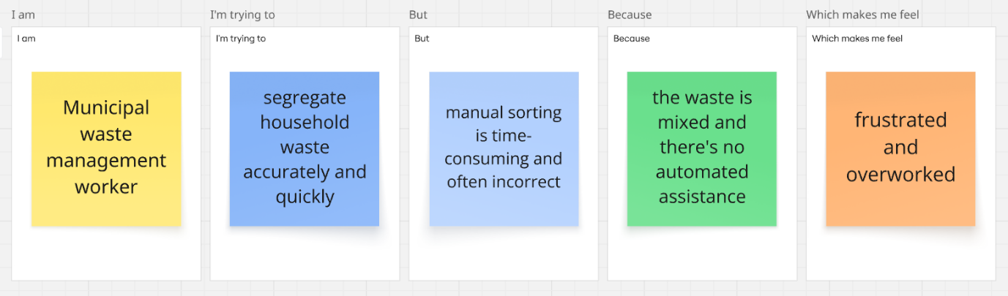

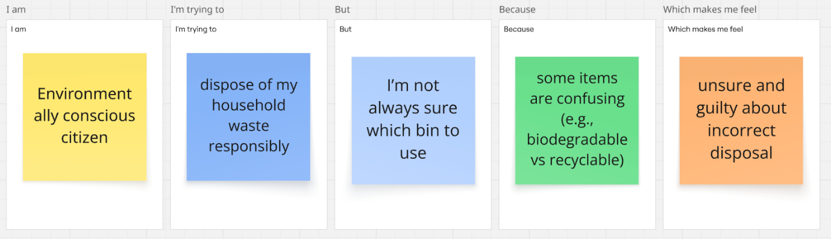

|  |  |  |  |  |  |
| --- | --- | --- | --- | --- | --- |
| **Problem Statement (PS)** | **I am (Customer)** | **I’m trying to** | **But** | **Because** | **Which makes me feel** |
| PS-1 | a municipal waste management worker | segregate household waste accurately and quickly | manual sorting is time-consuming and often incorrect | the waste is mixed and there's no automated assistance | frustrated and overworked |
| PS-2 | an environmentally conscious citizen | dispose of my household waste responsibly | I’m not always sure which bin to use | some items are confusing (e.g., biodegradable vs recyclable) | unsure and guilty about incorrect disposal |